A multistage graph G = (V, E) is a directed graph in which the vertices are partitioned into k ≥ 2 disjoint sets Vi , 1 ≤ i ≤ k.

• If 〈u, v〉 is an edge in E, then u ∈ Vi and v ∈ Vi+1. • The sets V1 and Vk are such that |V1 | = |Vk | = 1.

• The vertex s is the source and the t the sink (destination).

• The multistage graph problem is to find a minimum cost path from s to t.

• The cost of s to t is the sum of the cost of the edges on the path.

• The multistage graph problem can be solved in 2 ways.

* ¬Forward method
* ¬Backward method

Multistage Graphs Forward Approach

• In the forward approach, the cost of each and every node is found starting from the k stage to the 1st stage.

• The minimum cost path from the source to destination is found ie., stage 1 to stage k.

• For forward approach, Cost(i ,j) = min{c(j, l) + cost(i+1, l)} l∈Vi+1 〈j, l〉∈E where i is the level number.

• Time complexity: O(|V|+|E|)

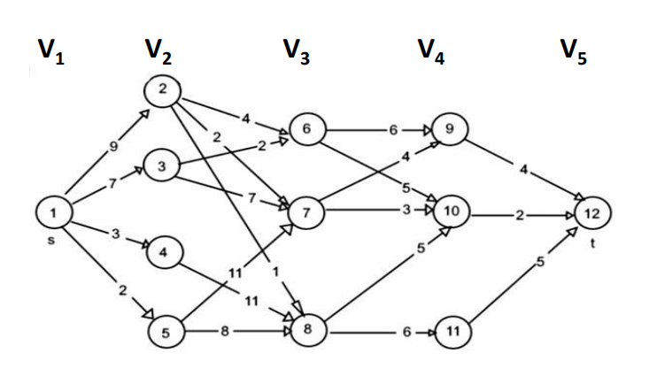

**Cost(i ,j) = min{c(j, l) + cost(i+1, l)} l∈Vi+1 〈j, l〉∈E**

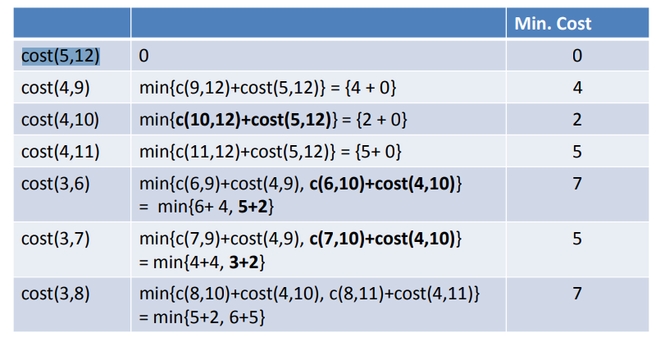

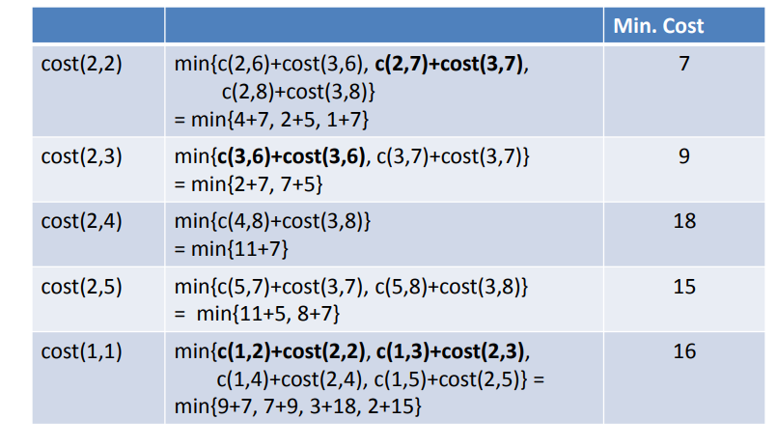

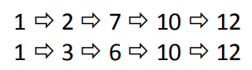

A multistage graph G=(V, E) is a directed and weighted graph in which vertices are divided into stages (the first stage and last stage of which will have a single vertex to represent the starting vertex or ending vertex).

In between the starting and ending vertex, there will vertices in different stages that connect the starting and ending vertex.

The main aim of this graph is to find the *minimum cost path between starting and ending vertex*.

Consider the following example graph to further understand the multistage graph:

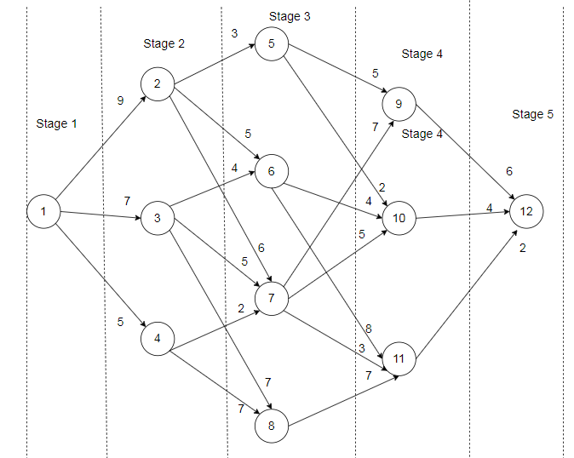

In the above graph, cost of an edge is represented as c(i, j).

We need to find the minimum cost path from vertex 1 to vertex 12. Using the below formula we can find the shortest cost path from source to destination: cost(i,j)=min{c(j,l)+cost(i+1,l)}*cost*(*i*,*j*)=*minc*(*j*,*l*)+*cost*(*i*+1,*l*)

**Step 1**

Step 1 uses the forwarded approach (cost(5,12) = 0 ).  
Here, 5 represents the stage number and 12 represents a node in that stage. Since there are no outgoing edges from vertex 12, the cost is 0.

**Step 2**

cost(4,9)=c(9,12)=6  
cost(4,10)=c(10,12)=4 cost(4,11)=c(11,12)= 2

**Step 3**

cost(3,5)=min{c(5,9)+cost(4,9),c(5,10)+cost(4,10)}  
min{5+6,2+4}  
min{11,6}=6  
cost(3,5)=6

cost(3,6)=min{c(6,10)+cost(4,10),c(6,11)+cost(4,11)}  
min{4+4,8+2}  
min{8,10}=8  
cost(3,6)=8

cost(3,7)=min{c(7,9)+cost(4,9),c(7,10)+cost(4,10),c(7,11)+cost(4,11)} min{7+6,5+4,3+2}  
min{13,9,5}=5  
cost(3,7)=5

cost(3,8)=c(8,11)+cost(4,11)=7+2=9 cost(3,8)=9

**Step 4**

cost(2,2)=min{c(2,5)+cost(3,5),c(2,6)+cost(3,6),c(2,7)+cost(3,7)} min{3+6,5+8,6+5}  
min{9,13,11}=9  
cost(2,2)=9

cost(2,3)=min{c(3,6)+cost(3,6),c(3,7)+cost(3,7),c(3,8)+cost(3,8)} min{4+8,5+5,7+9}  
min{12,10,16}=10  
cost(2,3)=10

cost(2,4)=min{c(4,7)+cost(3,7),c(4,8)+cost(3,8)}  
min{2+5,7+9}  
min{7,16}=7  
cost(2,4)=7

**Step-5**

cost(1,1)=min{c(1,2)+cost(2,2),c(1,3)+cost(2,3),c(1,4)+cost(2,4)} min{9+9,7+10,5+7}  
min {18,17,12}=12  
cost(1,1)=12

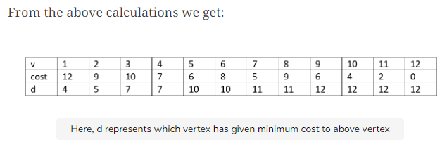

From the above calculations we get:

Here, d represents which vertex has given minimum cost to above vertex

Therefore:

 d[1]=4                             
 d[4]=7                       
 d[7]=11                     
 d[11]=12  
shortest path 1--4--7--11--12 i.e 12